Assignment on Git Command:

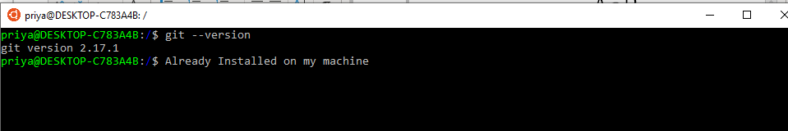

For Installing git: **sudo app-get install git**

Cloning one of my repository:

For Private repository I am getting error:

<https://github.com/priyagup/Array-HashTable-HashMap-HashSets-Tree>

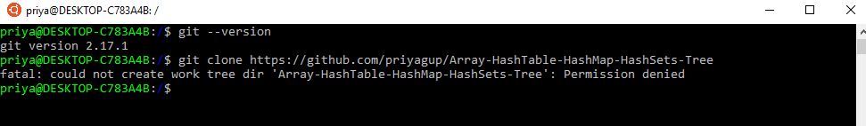

For Public repository:

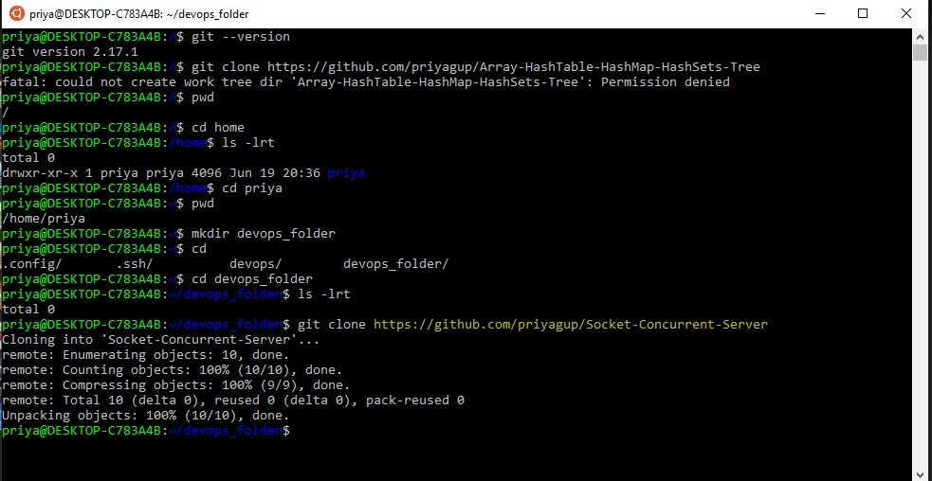

Inside the GitHub repository:

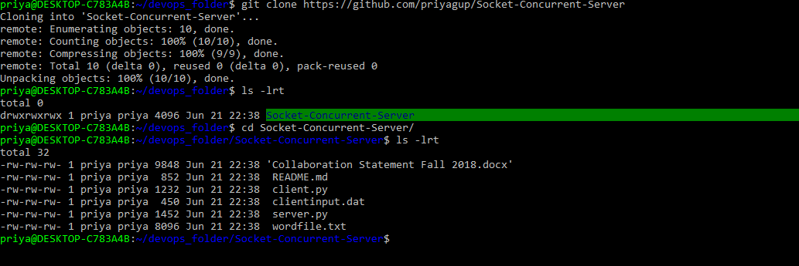

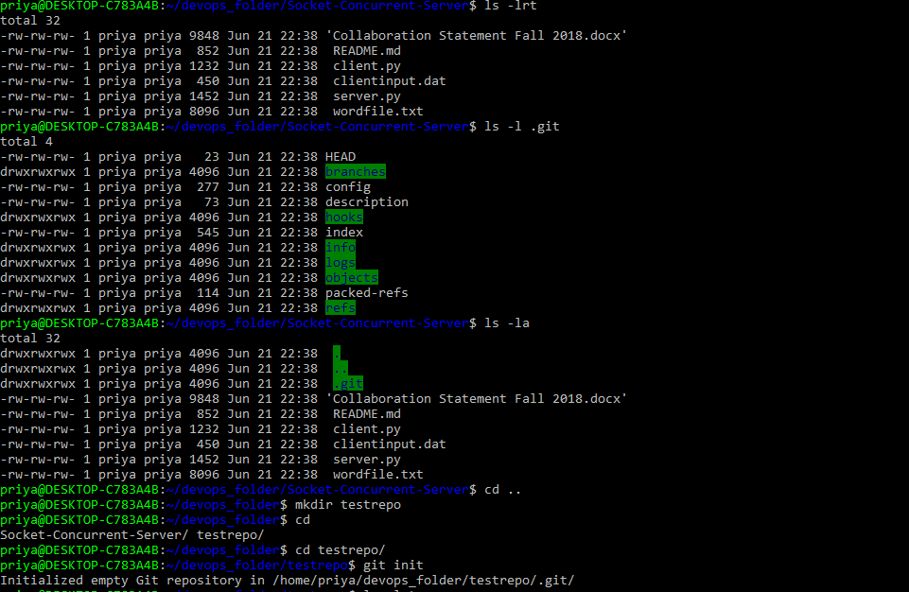

Adding file into git repository:

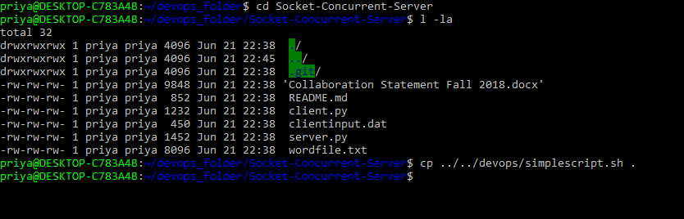

Removing from file from directory while present on another:

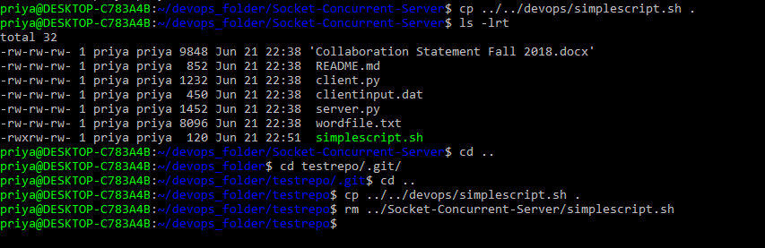

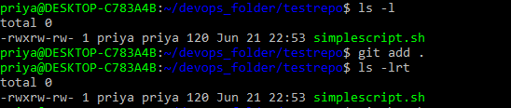



Checking status:





Trying to commit first time:



Configure the username and name:



Check:



Pushed the local repo to github:

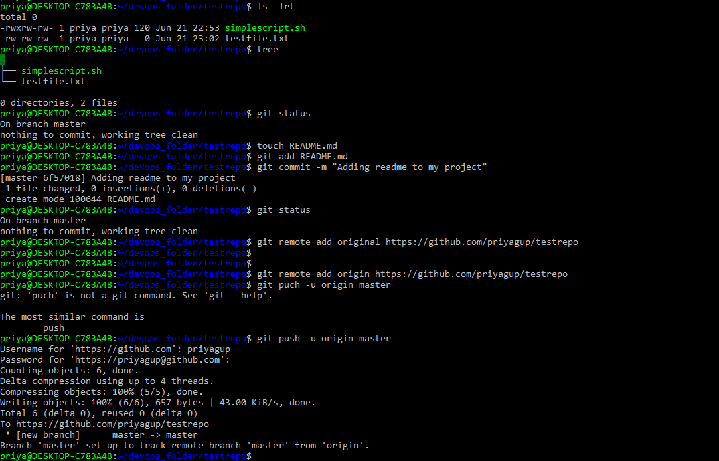

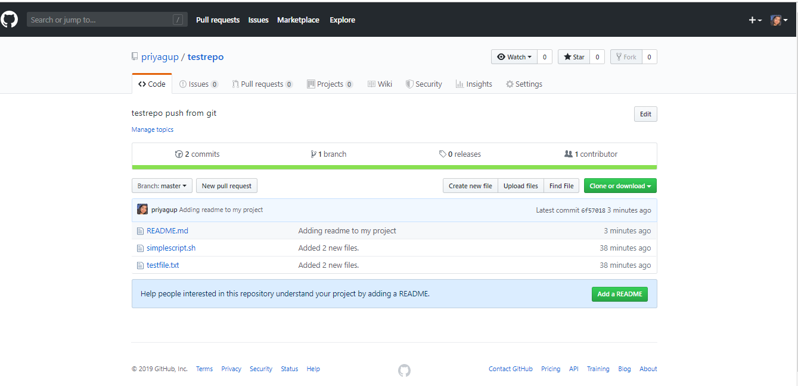

Creating branch:

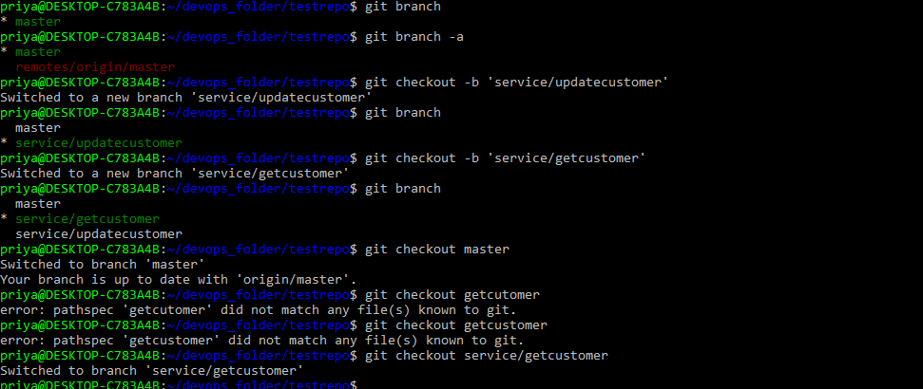

But not updated on GitHub:

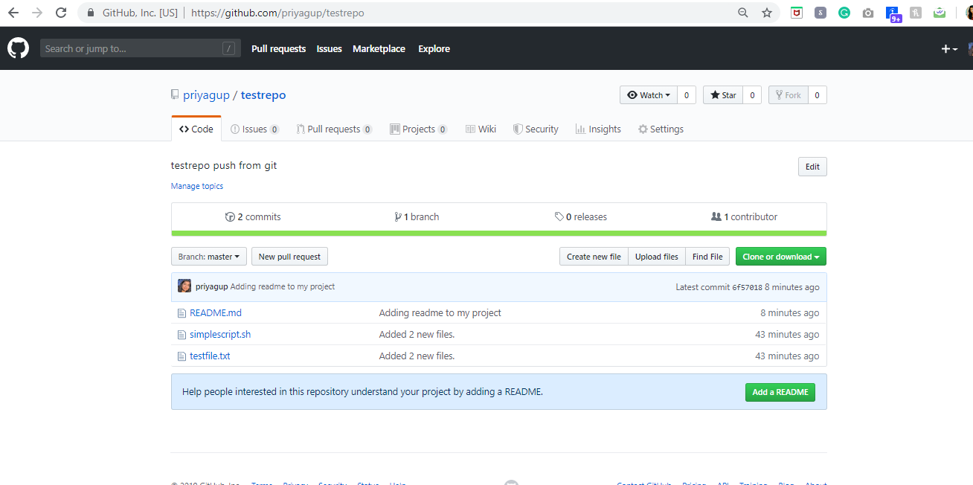

Adding more changes:



Added that changed on service/getcustomer branch:



Push the changes:

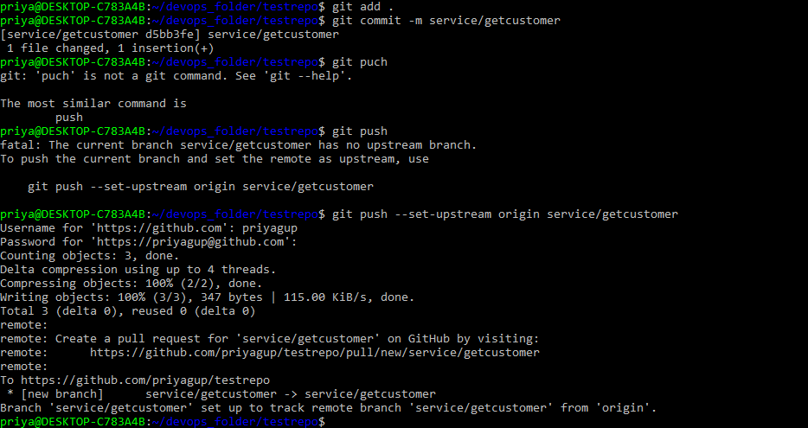

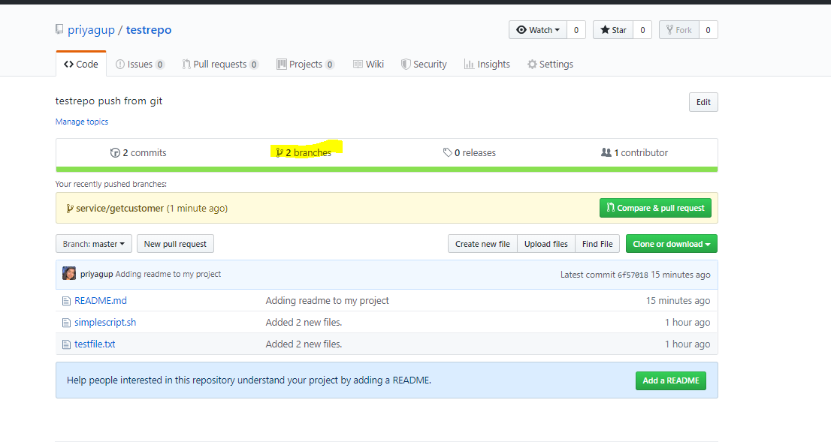

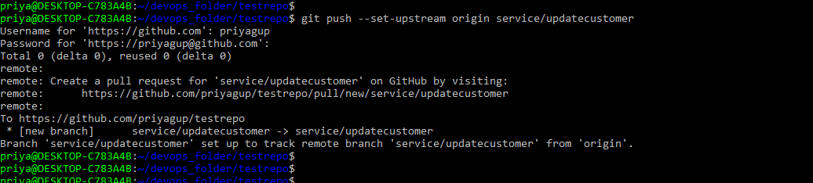



Check the changes history:

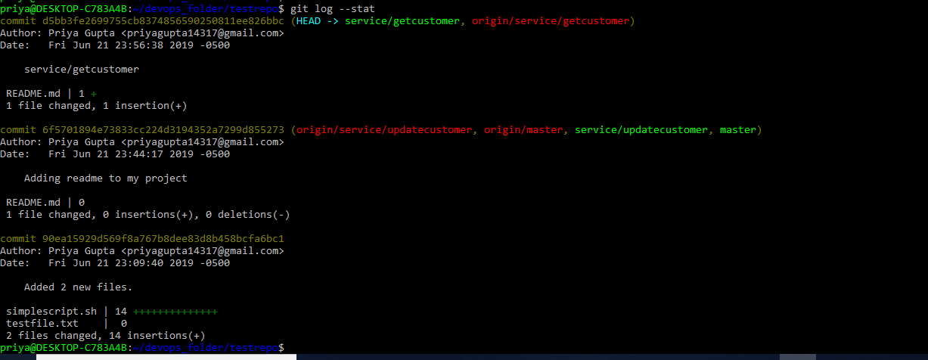

Check the code changes : git log -p

